**Document;**

The document object represents a web page that is loaded in the browser. By accessing the document object, we can access the element in the HTML page. With the help of document objects, we can add dynamic content to our web page. The document object can be accessed with a **window.document**or just**document.**

* Document and window object for javascript.
* Window object and document object are not the Ssame
* Javascript window object with document loaded
* The window is the first thing that gets loaded into the browser .
* This window object has the majority of the properties like length ,innerwidth,innerheight,name
* If it has been closed

## The Document Object

When an HTML document is loaded into a web browser, it becomes a **document object**.

The **document object** is the root node of the HTML document.

The **document object** is a property of the **window object**.

The **document object** is accessed with:

write a blog on the difference between document and window object

There seems to be a lot of misconceptions on the difference between the

document and window objects for javascript.

WINDOW object and DOCUMENT object ARE NOT THE SAME!!!!!

I have set out to clarify this for you in the most visual manor as possible.

So, what is the difference between the document object and window object you ask? Good question

write a blog on the difference between document and window object

There seems to be a lot of misconceptions on the difference between the

document and window objects for javascript.

WINDOW object and DOCUMENT object ARE NOT THE SAME!!!!!

I have set out to clarify this for you in the most visual manor as possible.

So, what is the difference between the document object and window object you ask? Good question

write a blog on the difference between document and window object

There seems to be a lot of misconceptions on the difference between the

document and window objects for javascript.

WINDOW object and DOCUMENT object ARE NOT THE SAME!!!!!

I have set out to clarify this for you in the most visual manor as possible.

So, what is the difference between the document object and window object you ask? Good question

document and window objects for javascript.

WINDOW object and DOCUMENT object ARE NOT THE SAME!!!!!

I have set out to clarify this for you in the most visual manor as possible

document and window objects for javascript.

WINDOW object and DOCUMENT object ARE NOT THE SAME!!!!!

I have set out to clarify this for you in the most visual manor as possible

document and window objects for javascript.

WINDOW object and DOCUMENT object ARE NOT THE SAME!!!!!

I have set out to clarify this for you in the most visual manor as possible

* exex

e

* ex:
* let url = window.document.URL;
* ex
* let url = document.URL;
* 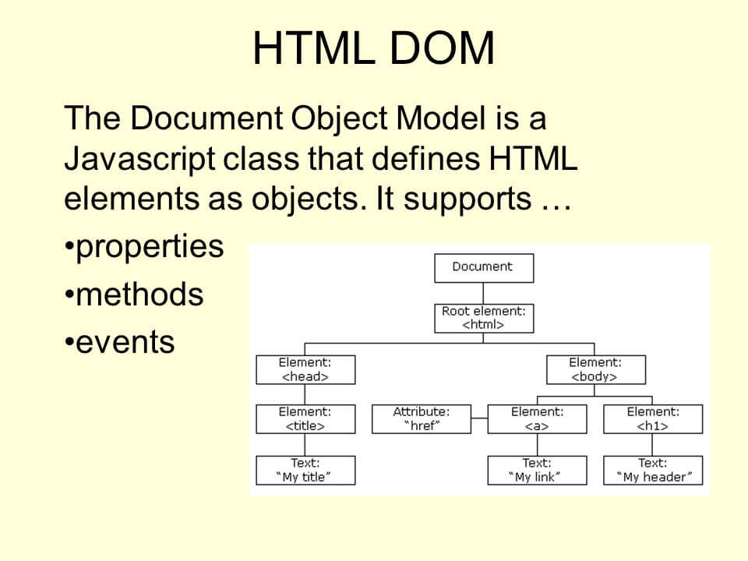

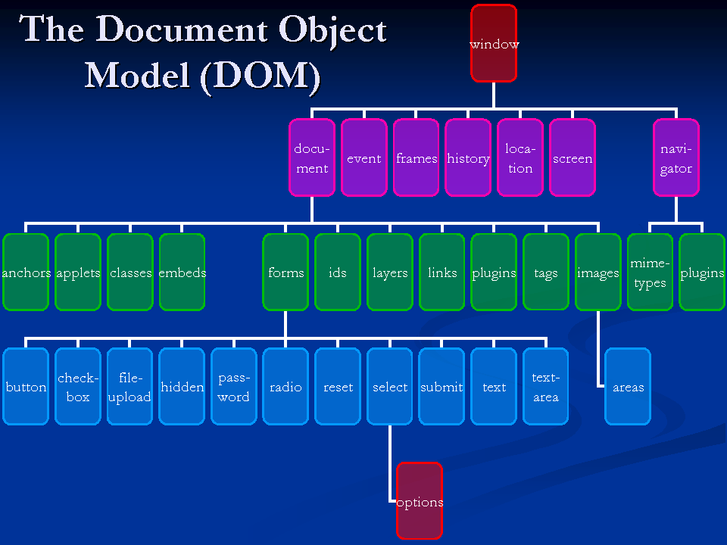

## Window Object

The window object represents an open window in a browser.

If a document contain frames (<iframe> tags), the browser creates one window object for the HTML document, and one additional window object for each frame.

